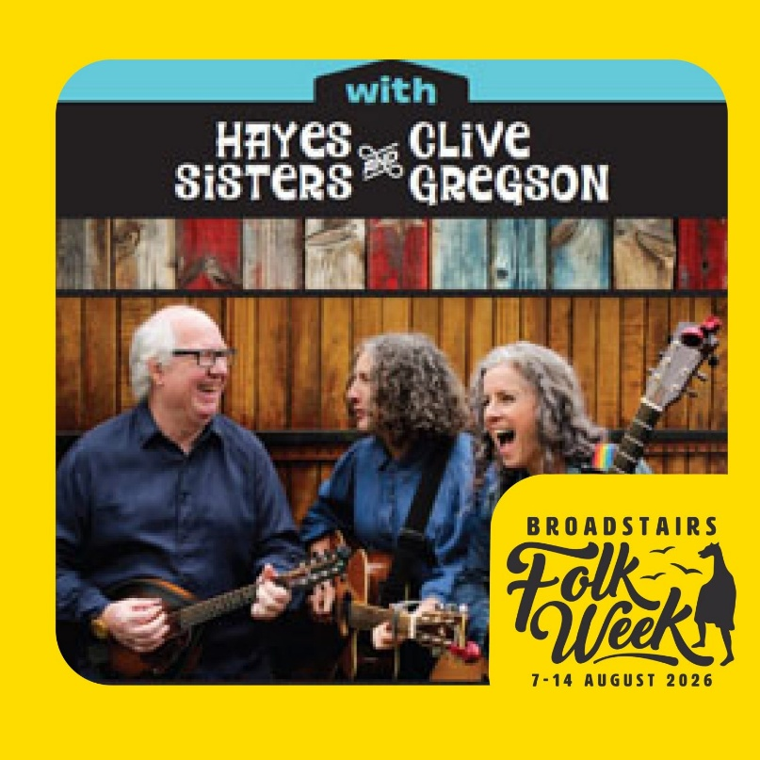

‘Love at the Five & Dime’ Remembering Nanci Griffiths, Supported by Will Allen’s Sun in the Sands’ Trio – Broadstairs Folk Week
Acclaimed vocalist, songwriter, guitarist and mandolin player Clive Gregson brings his rich musical legacy to this special collaboration celebrating the songs of Nanci Griffith. From 1996–2007, Gregson toured as a key member of Griffith’s Blue Moon Orchestra, and her recording of his song I Love This Town became a radio hit in both the UK and the US in 2006. Gregson’s remarkable career also includes the cult band Any Trouble, work with Richard Thompson, and his acclaimed duo Gregson and Collister.
Joining him are Stockport-based sisters Angela and Cathryn— The Hayes Sisters —
celebrated for their beautifully matched sibling harmonies. Described by Grateful Fred as having “those sibling harmonies you can’t buy,” their sound draws comparisons with The Roches and The McGarrigles, bringing warmth, precision and emotional clarity to every performance.
Gregson first encountered the Hayes Sisters while producing their debut album Another Man’s Shoes. A shared love and deep respect for Nanci Griffith’s songwriting quickly sparked the idea for this collaboration — an intimate, heartfelt celebration of a much-loved catalogue, delivered by artists uniquely connected to the music.
Supported by Will Allen’s Sun in the Sands’ Trio
This is a rare performance of Will Allen’s Sun in the Sands trio’s 2026 eponymous debut album.Owen Spafford (The Weaving; Spafford Campbell) on fiddle and Will Allen (Brown Boots; Club Debris) on viola/melodeon, are joined by Ben-Filmer-Sankey – one of the most in-demand guitarists on the London scene.
Buy Tickets – 'Love at The Five & Dime' - Remembering Nanci Griffiths (Supported by Will Allen's Sun in the Sand's Trio) (Concert) – Queens Road Baptist Church

